**Lesson – 4**

**Fibre to fabric**

**I. Word focus**

1. Fibre

2. Fabric

3. Weaving

4. Knitting

5. Retting

6. Boll

7. Yarn

8.

**II. KWL Chart**

**III. Answer the following**

1. What is the difference between weaving and knitting in the process of making fabric?

| **Aspect** | **Weaving** | **Knitting** |
| --- | --- | --- |
| **Definition** | Interlacing two sets of threads  (warp and weft) | Interlocking loops of a single thread or yarn |
| **Thread Direction** | Uses two sets: warp (vertical) and weft (horizontal) | Uses one continuous thread or yarn |
| **Tools Used** | Usually done on a **loom** | Done using **knitting needles** or machines |
| **Fabric Texture** | Produces a **firm and strong** fabric | Produces a **soft and stretchy** fabric |
| **Examples** | Cotton cloth, denim, sarees | Sweaters, woollen caps, socks |
| **Elasticity** | Less elastic | More elastic |
| **Speed** | Slower and more structured process | Can be faster for simple patterns |

2. Compare and contrast natural fibres like cotton and synthetic fibres like polyester, giving two points for each.

| **Aspect** | **Natural Fibres (plant/animal‑based)** | **Synthetic Fibres (man‑made)** |
| --- | --- | --- |
| **Source** | Harvested from plants (e.g., cotton bolls, flax) or animals (e.g., wool, silk) | Produced from petrochemicals or regenerated polymers (e.g., polyester, nylon, acrylic) |
| **Biodegradability** | **Biodegradable**—break down naturally | **Non‑biodegradable**—persist in the environment |
| **Breathability & Comfort** | Highly breathable; feel cool and comfortable on skin | Generally less breathable; can trap heat and moisture |
| **Wrinkling** | Tend to wrinkle easily | Naturally wrinkle‑resistant |
| **Drying Time** | Absorb more moisture—**slow to dry** | Low moisture absorption—**quick‑drying** |

3. A school is organizing an eco-friendly craft fair and wants to use plant-based fibres for decorations. Suggest two plant fibres other than cotton and jute, and explain how they can be used.

a) Coir:

Coir, obtained from coconut husks, can be twisted into ropes or woven into mats for decorative hangings or table covers. It is strong and water-resistant.

b) Hemp:

Hemp fibres, from the hemp plant, can be used to make durable strings or woven into fabric for banners. It is eco-friendly and sturdy.

4. Imagine a picture showing a cotton field with cotton bolls. Describe the steps involved in producing cotton fabric from the cotton bolls shown in the picture.

(Give the answer in foldable)

The steps to produce cotton fabric from cotton bolls are:

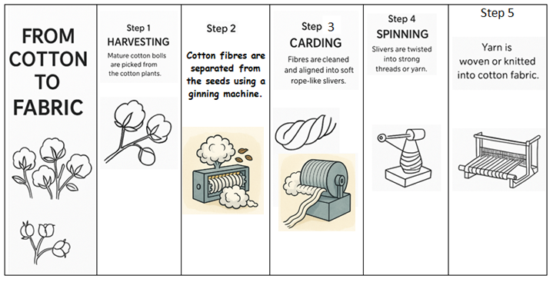

5. In a coastal village, people use jute and coir to make products like bags and mats. Explain the process of obtaining jute fibre from the jute plant.

**Process of Obtaining Jute Fibre:**

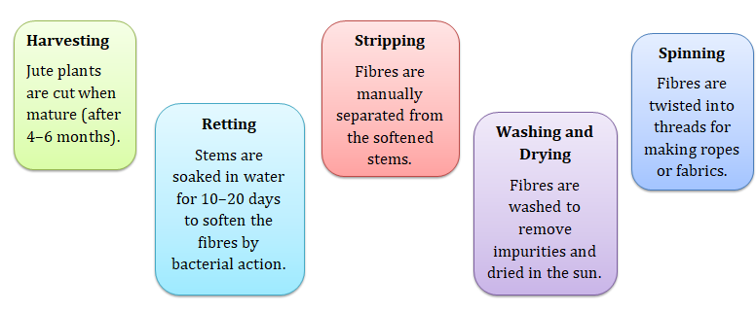

**IV. Activity**

1. Weave a mat using two different color papers

2. Knit a piece using wool and stick here